Curso de Inglês

Professor: Luis Felipe

Aluno: Luiz Perciliano

Programa: Class#9_2021

**Sumário**

1. Semana 33 – de 16 de agosto a 22 de agosto 3

2. Semana 34 – de 22 de agosto a 28 de agosto 3

3. Semana 35 – de 28 de agosto a 04 de setembro – Unit 16 4

4. Semana 36 – de 04 de agosto a 0x de setembro – Unit 16 5

5. Semana 38 – de 20 de setembro a 0x de setembro – Book 1 Unit 14, 15 and 16 10

6. Semana 39 – de 26 de setembro a 02 de outubro – Book 2 Unit 1 12

7. Referências 13

# **Semana 33 – de 16 de agosto a 22 de agosto**

Unit 10 = <https://www.youtube.com/watch?v=MpkVVksji4Y>

**Estudo dia (17/08/2021):** WorkBook, Unit 10, exercise 3.

**Estudo dia (18/08/2021 00:29h):** WorkBook, Unit 10, exercise 4 – OK

**Estudo dia (18/08/2021 22:38h a 23:12h):** WorkBook, Unit 10, exercise 5 at 10 – ok

**Unit 11**

I AM GOING TO HAVE A PARTY- INTERCHANGE INTRO 5TH EDITION UNIT 11 AUDIO PROGRAM

<https://www.youtube.com/watch?v=YQtXPmLAoEM&t=5s>

Listen unit eleven complete.

**Estudo dia (19/08/2021 23:14h a 00:20h):** WorkBook, Unit 11 exercise 1 at 2

**Estudo dia (20/08/2021 23:44h a 00x:37h):** WorkBook, Unit 11 exercise 3 at 5.1

Interchange INTRO 5th edition - Unit 11A 👉👉 SUBSCRIBE 👈👈

<https://www.youtube.com/watch?v=ngCd0g8QrEM&list=PL2eIVQX0_SVcB-neEUAK6OrN0z0Xf9FTS&index=21>

**Estudo dia (21/08/2021 08:00h a 10:00h):** Aula no Zoom com teacher e guys.

**Homework:** Lesson 10, 11 and 15 cap 7b em diante.

It made lesson 10 until 11 5.1

# **Semana 34 – de 22 de agosto a 28 de agosto**

**Study day (23/08/2021 22:31h a 23:27h):**

WorkBook: **: Unit** 11, exercice 5.2 at exercise 7

Book, Unit 15 exercise 7 B em diante (page)

Refazer toda a lição 7

**Study day (24/08/2021 22:47h a 23:16h):**

Drops - OK

Book, Unit 15 exercise 7 B em diante - OK

Refazer toda a lição 7 – OK

To make 8 – Word Power (vídeo 12:00minutes)

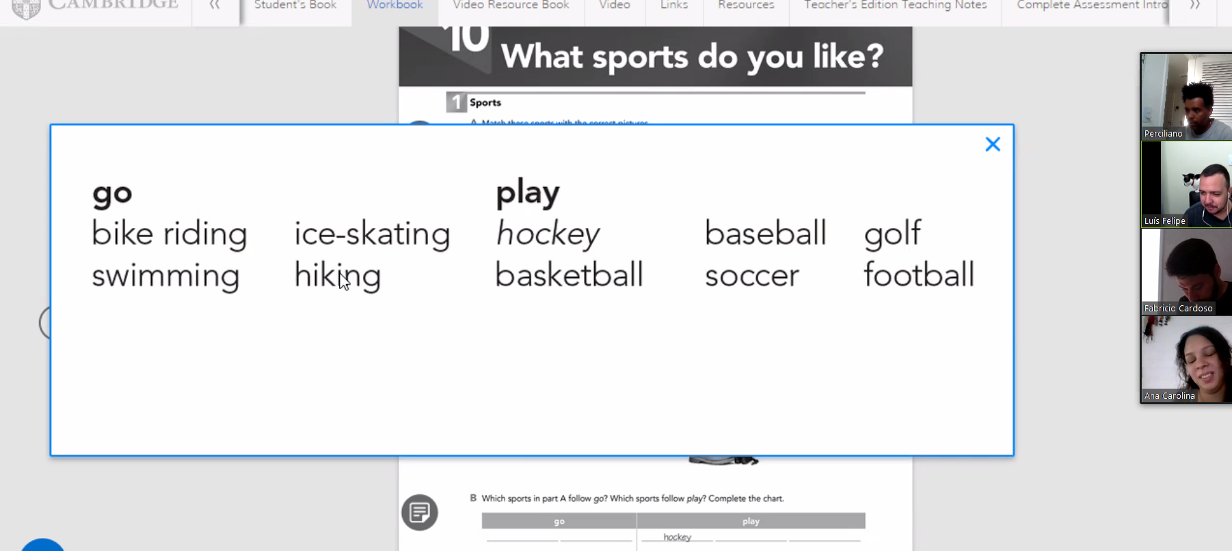

Unit 15 links

Interchange INTRO 5th edition WHERE WERE YOU BORN?

* WHERE WERE YOU BORN ?

<https://youtu.be/OI0vkiif5uI> (listen in 23/08/21)

listen again and to make exercise seven

* Unit 15A - <https://youtu.be/tSmaZdmrZ0U?list=PL2eIVQX0_SVcB-neEUAK6OrN0z0Xf9FTS>
* Unit 15B - <https://youtu.be/yLJ-kqkfsL8?list=PL2eIVQX0_SVcB-neEUAK6OrN0z0Xf9FTS>

Book, Unit 15 exercise 7 B (page) em diante

**Homework: Unit** 11, exercice 5.1 and study unit 15 book 7b em diante. (23/08/2021 = OK)

# **Semana 35 – de 28 de agosto a 04 de setembro – Unit 16**

**Study day (28/08/2021 08:13h a 10:02h) – Botafogo-RJ**



Correct Units workbook 10 and 11.

**Study day (30/08/2021 23:20h* a 31/08/2021 00:50h) – Botafogo-RJ**

Workbook, unit 12, make until exercise 6.

To homework, to make workbook unit 11, 12 and 13

Unit 12 –

<https://www.youtube.com/watch?v=vEOuo1JC1aA> (listen 30/08/2021)

<https://www.youtube.com/watch?v=tIqNtQJGCEY&list=PL2eIVQX0_SVcB-neEUAK6OrN0z0Xf9FTS&index=24>

<https://www.youtube.com/watch?v=_FM3Ww-ZrbU&list=PL2eIVQX0_SVcB-neEUAK6OrN0z0Xf9FTS&index=25>

Unit 16

ESTARLING SILVESTRE

CAN I TAKE A MESSAGE ? interchange intro 5th edition unit 16 audio program

<https://www.youtube.com/watch?v=bbcjRqiyhnE>

Teacher Wilkins

<https://www.youtube.com/watch?v=YYQCuXjjvLg&list=PL2eIVQX0_SVcB-neEUAK6OrN0z0Xf9FTS&index=31>

<https://www.youtube.com/watch?v=rf5vDhOXkqI&list=PL2eIVQX0_SVcB-neEUAK6OrN0z0Xf9FTS&index=32>

**Study day (31/08/2021 23:26h a 01/09/2021 00:33h):**

To homework, to make workbook unit 12 exercise 7 and 8

**Study day (01/09/2021 22:18h a 01/09/2021 00:33h):**

Unit 13 - HOW DO I GET THERE ? - <https://www.youtube.com/watch?v=T4OR8SfyOcQ&t=19s>

To homework, to make workbook unit 13 - exercise 1 letter A and letter B.

**Study day (02/09/2021 22:00h a 03/09/2021 00:24h):**

To homework, to make workbook unit 13 - all

**Study day (03/09/2021 22:58h a 04/09/2021 00:30h):**

See every video <https://www.youtube.com/watch?v=bbcjRqiyhnE>

I need to make exercices of book and workbook.

# **Semana 36 – de 04 de agosto a 0x de setembro – Unit 16**

**Study day (04/09/2021 08:10h a 10:02h) – Botafogo-RJ**

Initial conversation Teacher

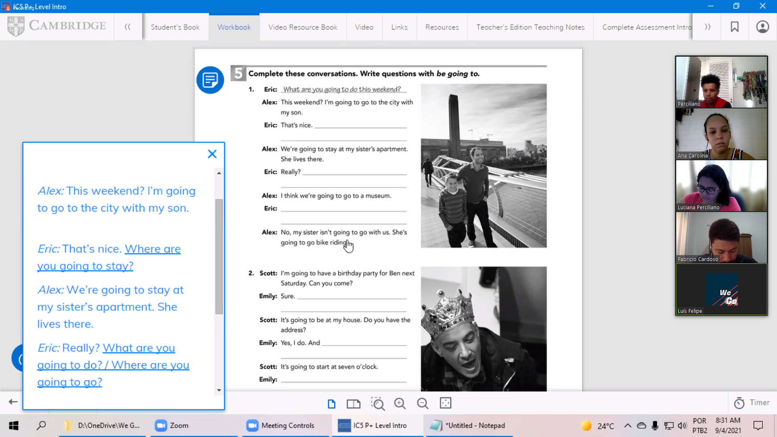

-

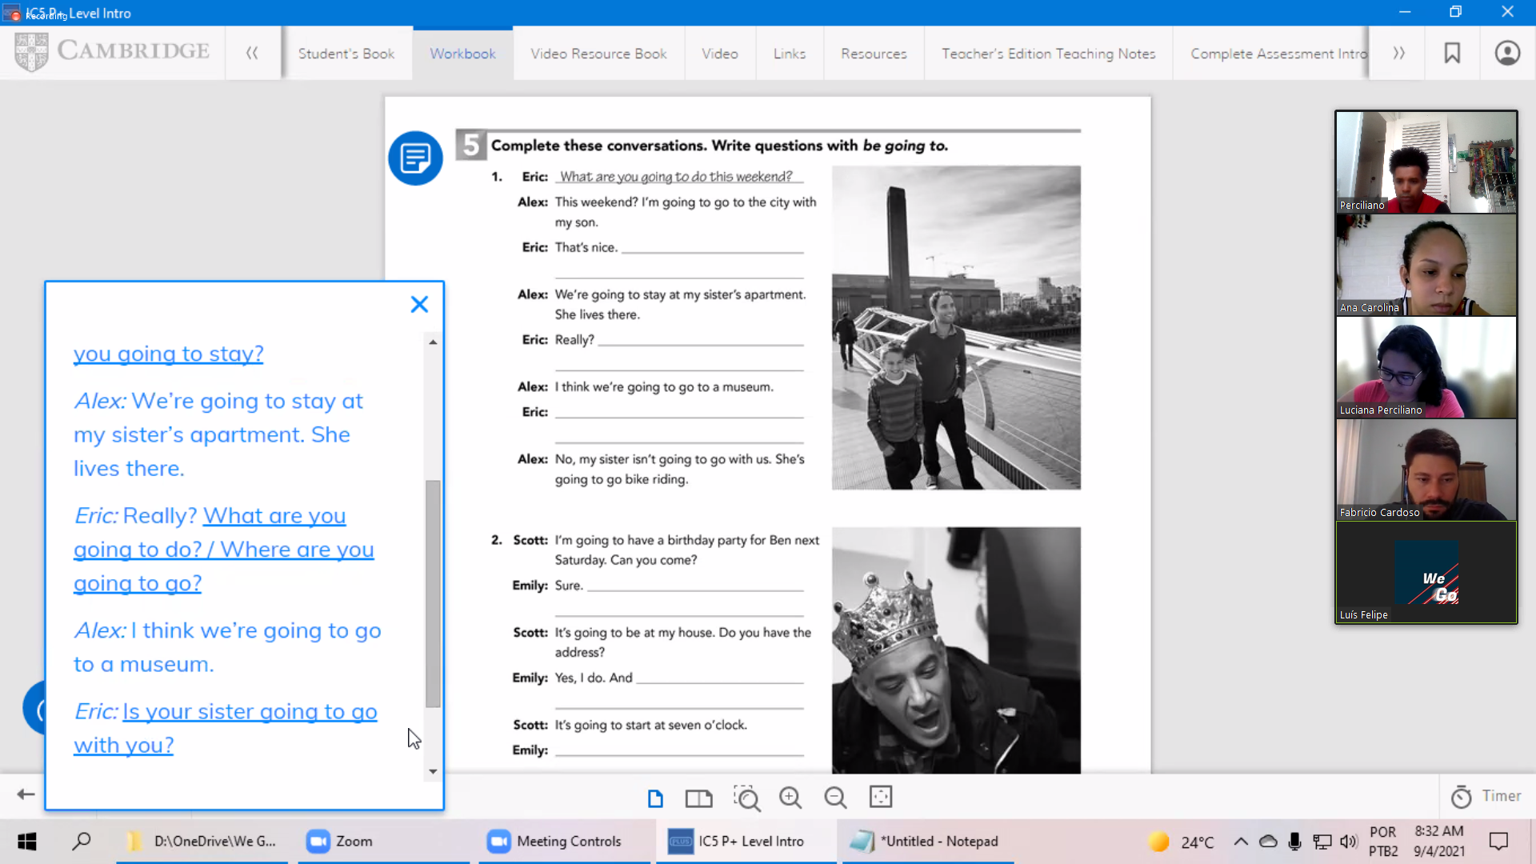

-

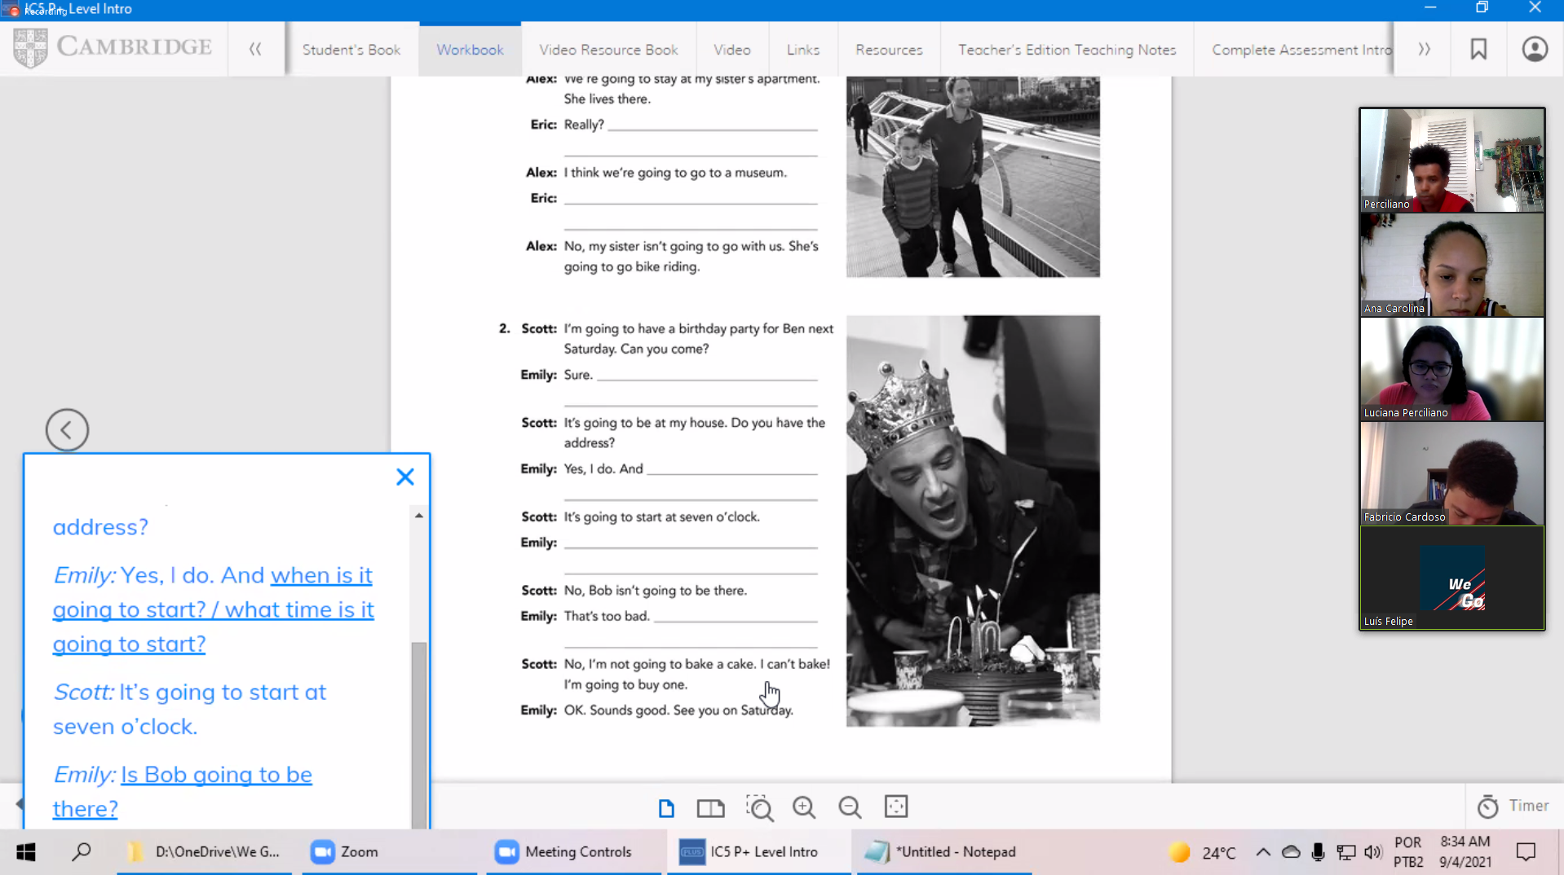

-

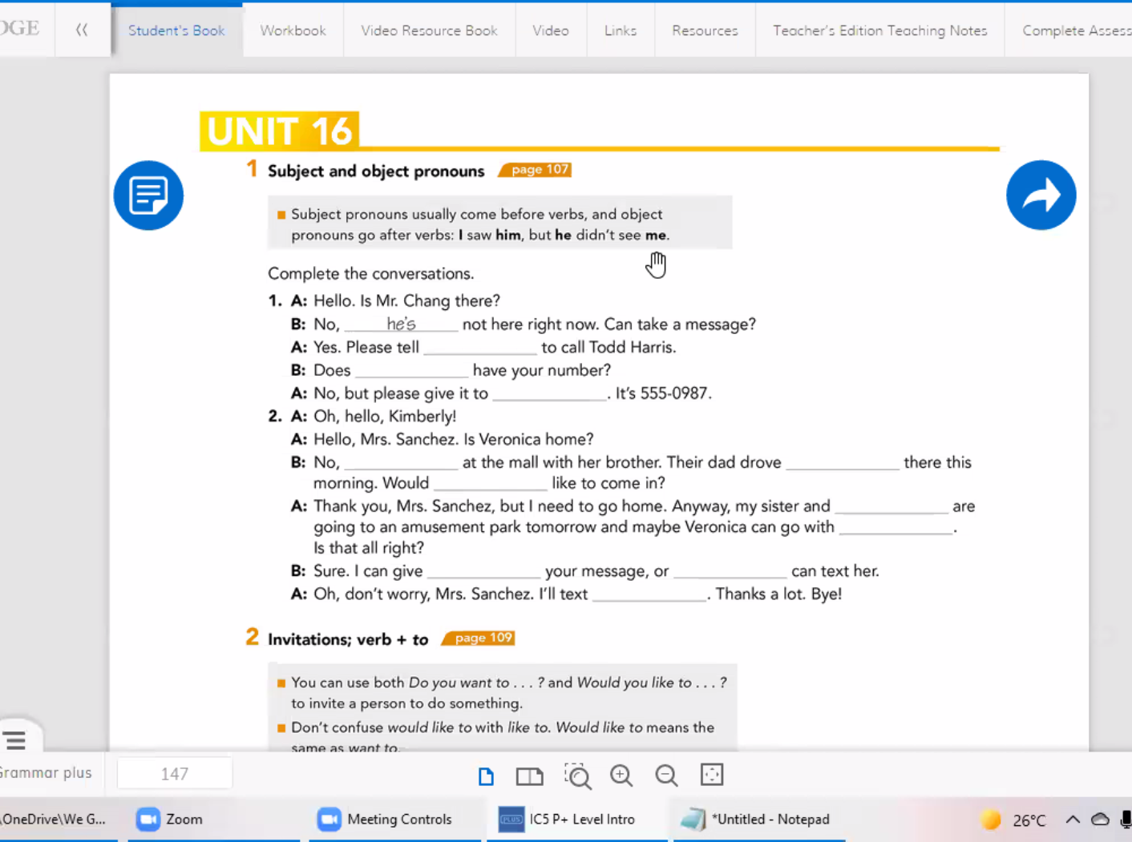

-

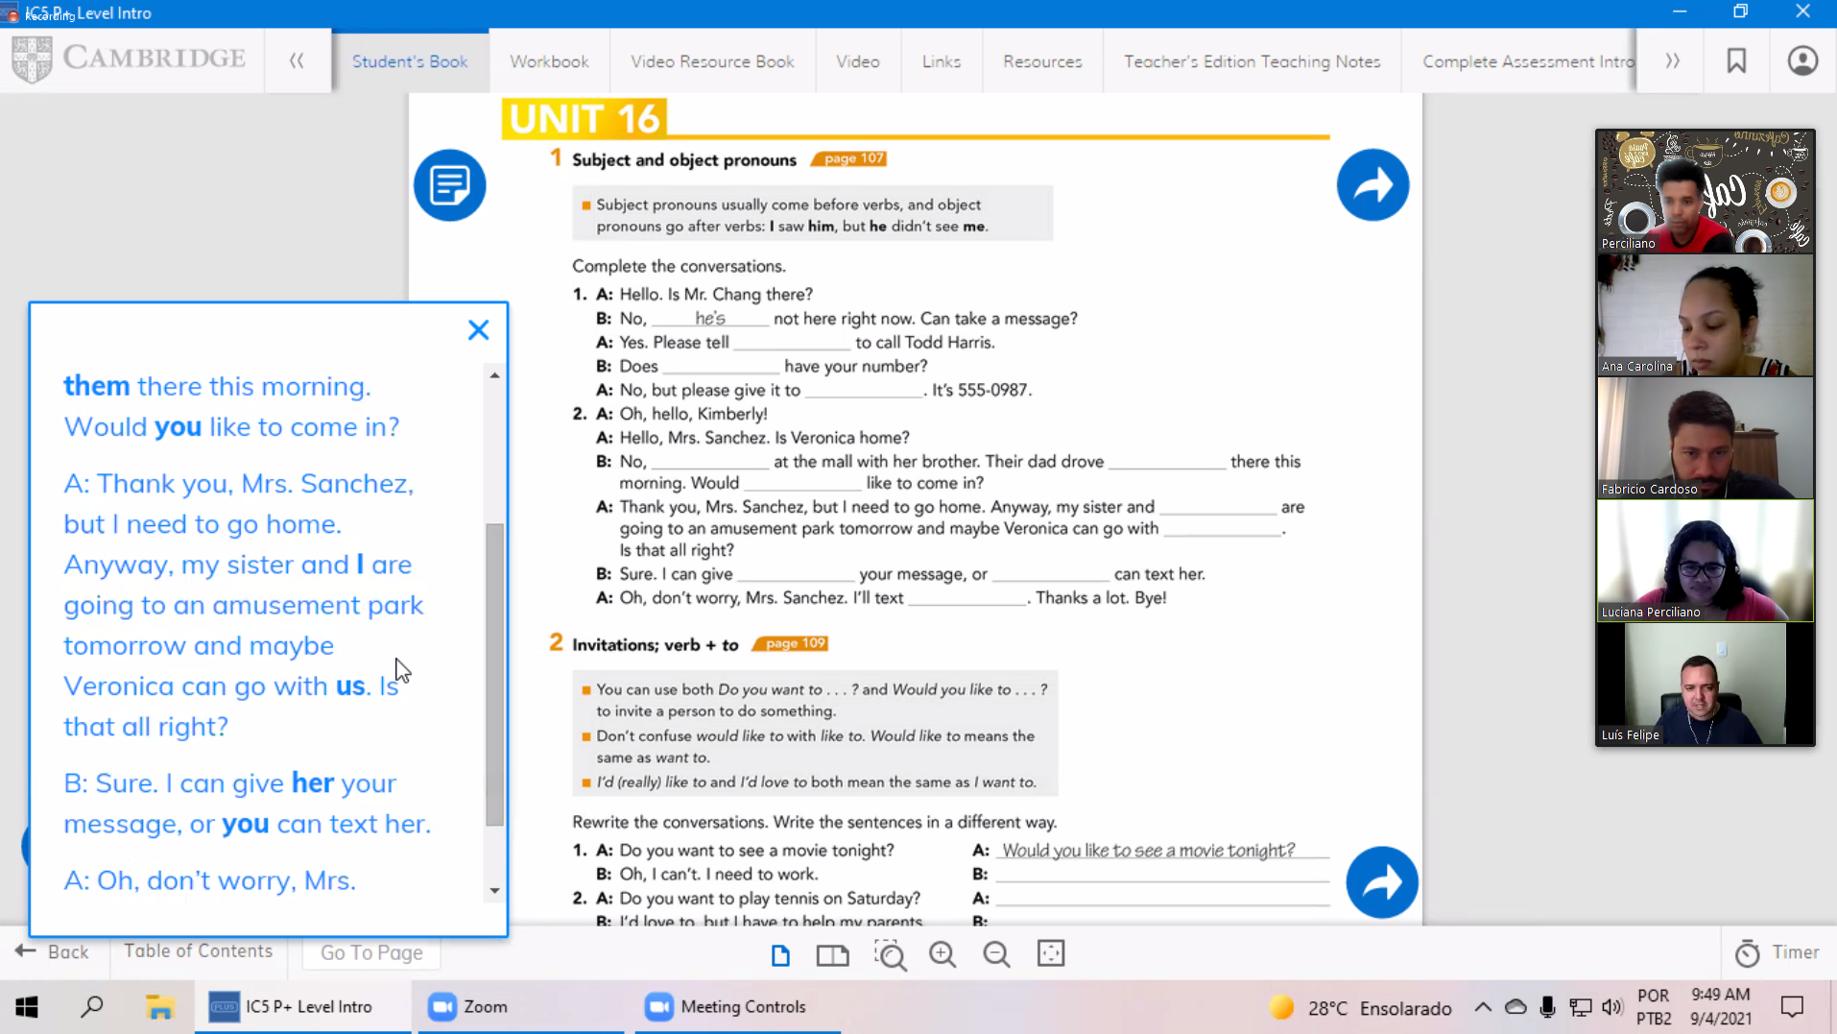

-

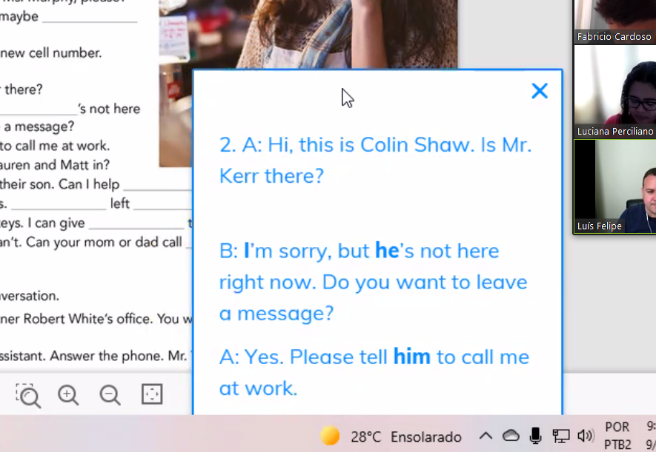

-

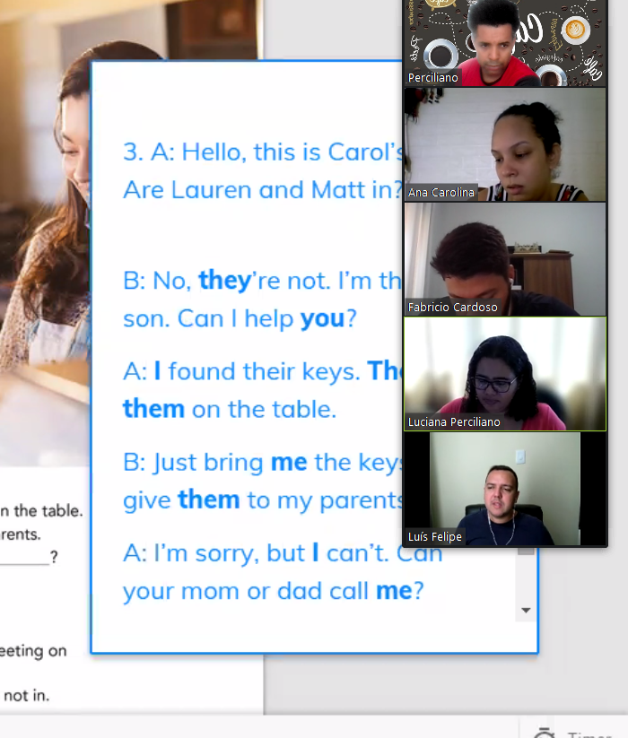

-

Study unit 16 until exercise 4 (grammar focus and grammar plus).

To make exercises unit 16 after exercise 4 from book and workbook unit 14, 15 and 16.

# **Semana 38 – de 20 de setembro a 0x de setembro – Book 1 Unit 14, 15 and 16**

Aula do dia 18, com prova, faltei

Unit 14 – I had a good time.

<https://www.youtube.com/watch?v=aLJj-jnJMR0>

* Book page 92 – 99 | pdf page 98
  + 1 Snapshot – page 92
  + 2 Conversation – page 92
  + 3 Grammar Focus – page 93
  + 4 Pronunciation – page 92
  + 5 Grammar Focus – page 94
  + 6 Speaking – page 94
  + 7 Conversation – page 95
  + 8 Grammar Focus – page 95
  + 9 Listening – page 96
  + 10 Word Power – page 96
  + 11 Interchange – page 94
  + 12 Reading – page 94
  + Units 13-14 – Progress check – page 98 – 99
* Workbook page 79 a 84 | pdf 82 - 87

**Study day (22/09/2021 19:57h a 01/09/2021 00:33h):**

* Busuu
* Drops - OK
* Duolingo
* News in levels
* To homework, to make workbook unit 14, 15 and 16

**Study day (23/09/2021 19:10h a ):**

* Busuu - OK
* Drops - OK
* Duolingo Italy - OK
* News in levels
  + Spain’s ugliest tomato
* To homework, to make workbook unit 14, 15 and 16
  + Finished unit 14
  + Finished unit 15 until exercise 5.

Unit 15 – Where were you born?

<https://www.youtube.com/watch?v=OI0vkiif5uI>

* Book page 100 – 105 | pdf page 106 - 111

1. Snapshot
2. Conversation - I was born in Brazil
3. Grammar Focus
4. Pronunciation
5. Conversation
6. Grammar Focus
7. Listening
8. Word Power
9. Speaking
10. Interchange 15
11. Reading

* Workbook page 85 a 90 | pdf 88 - 93

**Study day (24/09/2021 23:07h a 00:20h (day 25) ):**

* Busuu – OK

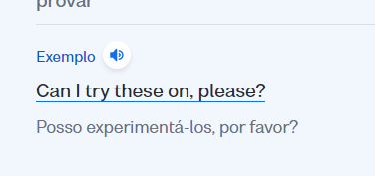

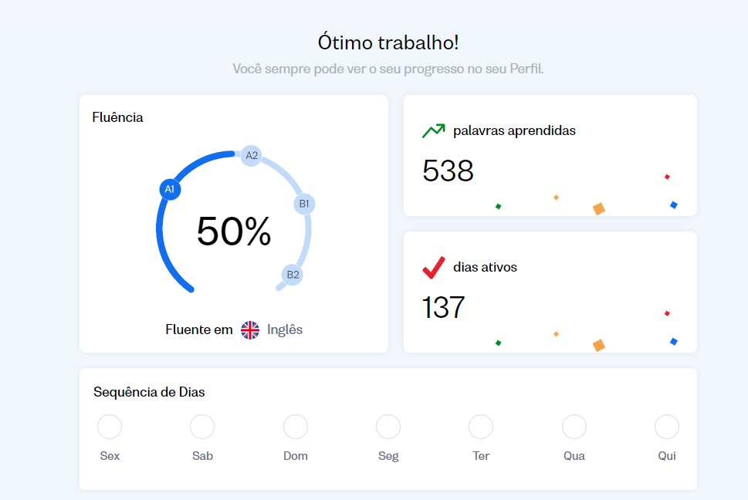

* Drops - OK
* Duolingo Italy - NOK
* News in levels - NOK
* To homework, to make workbook unit 14, 15 and 16
  + Finished unit 15.

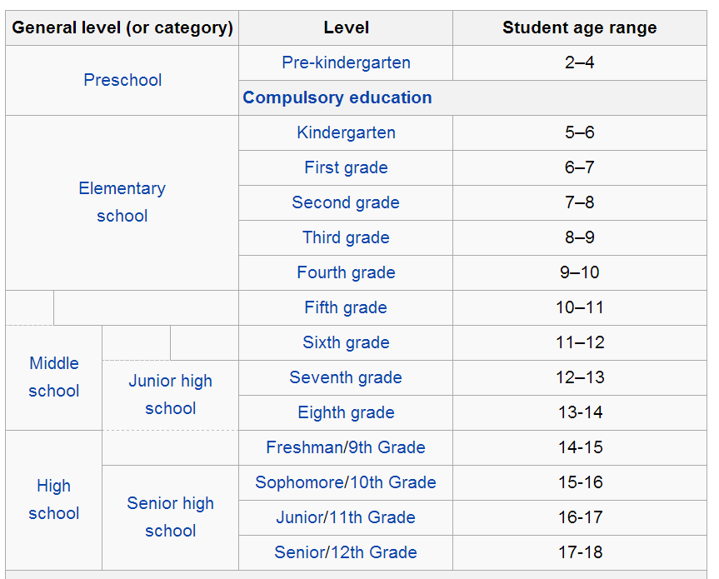

**Study day (Saturday - 25/09/2021):**

Don’t have class, the teacher was sick

# **Semana 39 – de 26 de setembro a 02 de outubro – Book 2 Unit 1**

**Study day (Sunday - 26/09/2021):**

* Drops - OK
* Busuu – OK - Lição 48: Eu gastei muito dinheiro ontem - Formando o simple past de verbos como "to spend"
* Duolingo Italy - OK
* News in levels - NOK

Unit 16 – Can I take a message?

<https://youtu.be/bbcjRqiyhnE>

https://quizlet.com/600860973/unit-16-interchange-5th-edition-intro-flash-cards/

<https://quizizz.com/admin/presentation/5f77638858c4aa001b2a5425/unit-can-i-take-a-message>

* Book page 106 – 113 | pdf page 112 - 119

1. Conversation
2. Word Power
3. Listening
4. Grammar Focus
5. Snapshot
6. Conversation
7. Pronunciation
8. Grammar Focus
9. Speaking
10. Listening
11. Interchange 16
12. Reading
13. Unit 15-16 Progress Check

* Workbook page 91 a 96 | pdf 94 – 99
  + Finished exercise 1 and 2.

**Study day (Sunday - 27/09/2021):**

* Drops - OK
* Duolingo Italy - OK
* Busuu – OK - Lição 49
  + This weekend i’m goin to to visit my mom. I hope so spend my time kidding.
* News in levels - NOK

**Book 2 – Playlist**

[**https://www.youtube.com/watch?v=uOx7h3Ew0xI&list=PLrE-TRIPaiR6jbFFzng5UD9fT8emtBz7R**](https://www.youtube.com/watch?v=uOx7h3Ew0xI&list=PLrE-TRIPaiR6jbFFzng5UD9fT8emtBz7R)

# **Referências**

Teacher Wilkins -

<https://www.youtube.com/channel/UCtjDh5Cp7Va9qh3CMnsfLrA>

Lessons record: <https://1drv.ms/u/s!AvGAHmvAFyVsk9A6Meosg1Znza2zIg?e=eof2xh>

<https://app.languagedrops.com/?_branch_match_id=969359611060418607>

<https://www.newsinlevels.com/>

https://www.duolingo.com/learn